Logic:

See all the positive number will be included in the product.

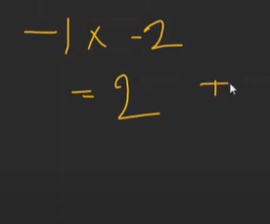

Also multiply 2 negative will give positive number.

See if even number was given take all the negative number and multiply but odd there like the above then take the smallest that Is not taking -1.

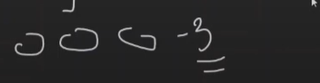

See this is edge case like we talked not take 0 and hence we take -1 but -3 is less than 0 and hence here ans should be 0.

Code:

